What is a Class Diagram in UML?
A class diagram describes the structure of an object-oriented system by showing the classes in that system and the relationships between the classes. A class diagram also shows constraints, and attributes of classes.
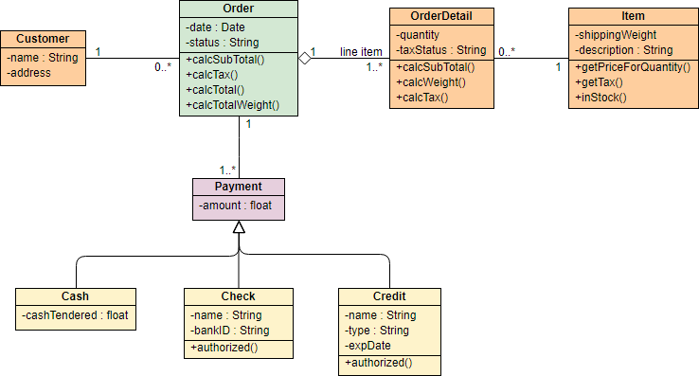

Class Diagram Notations

Class
The UML representation of a class is a rectangle containing three compartments stacked vertically, as shown in the Figure:
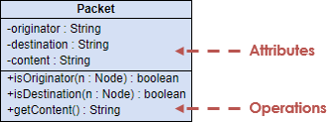

Attribute
The attribute section of a class lists each of the class's attributes on a separate line. The attribute section is optional, but when used it contains each attribute of the class displayed in a list format. The line uses this format: name : attribute type (e.g. cardNumber : Integer).

Operation
The operations are documented in the bottom compartment of the class diagram's rectangle, which also is optional. Like the attributes, the operations of a class are displayed in a list format, with each operation on its own line. Operations are documented using this notation: name (parameter list) : type of value returned (e.g. calculateTax (Country, State) : Currency).

Relationships

Association
Some objects are made up of other objects. Association specifies a "has-a" or "whole/part" relationship between two classes. In an association relationship, an object of the whole class has objects of part class as instance data.
In a class diagram, an association relationship is rendered as a directed solid line.
Unidirectional association - In a unidirectional association, two classes are related, but only one class knows that the relationship exists.
A unidirectional association is drawn as a solid line with an open arrowhead pointing to the known class.
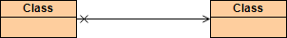
Bidirectional (standard) association - An association is a linkage between two classes. Associations are always assumed to be bi-directional; this means that both classes are aware of each other and their relationship, unless you qualify the association as some other type.
A bi-directional association is indicated by a solid line between the two classes.
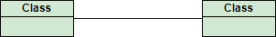

Multiplicity
Place multiplicity notations near the ends of an association. These symbols indicate the number of instances of one class linked to one instance of the other class. For example, one company will have one or more employees, but each employee works for one company only.
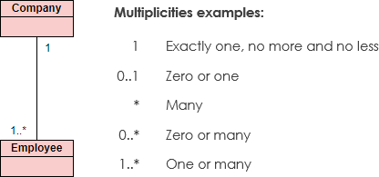

Visibility
Visibility is used to signify who can access the information contained within a class denoted with +, -, # and ~ as show in the figure:
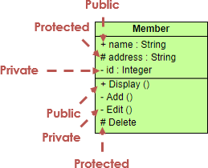

Generalization
A generalization is a relationship between a general thing (called the superclass) and a more specific kind of that thing (called the subclass). Generalization is sometimes called an "is a kind of" relationship and is established through the process of inheritance.
In a class diagram, generalization relationship is rendered as a solid directed line with a large open arrowhead pointing to the parent class.
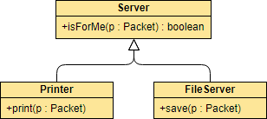

Abstract Classes and methods
In an inheritance hierarchy, subclasses implement specific details, whereas the parent class defines the framework its subclasses. The parent class also serves a template for common methods that will be implemented by its subclasses.
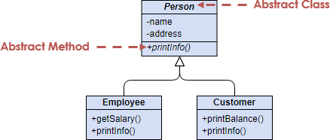
The name of an abstract Class is typically shown in italics; alternatively, an abstract Class may be shown using the textual annotation, also called stereotype {abstract} after or below its name.
An abstract method is a method that do not have implementation. In order to create an abstract method, create a operation and make it italic.

Realization
A realization is a relationship between two things where one thing (an interface) specifies a contract that another thing (a class) guarantees to carry out by implementing the operations specified in that contract.
In a class diagram, realization relationship is rendered as a dashed directed line with an open arrowhead pointing to the interface.
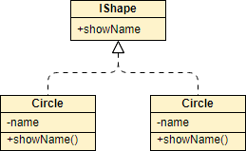

Dependency
Dependency indicates a "uses" relationship between two classes. In a class diagram, a dependency relationship is rendered as a dashed directed line.
If a class A "uses" class B, then one or more of the following statements generally hold true:
- Class B is used as the type of a local variable in one or more methods of class A.
- Class B is used as the type of parameter for one or more methods of class A.
- Class B is used as the return type for one or more methods of class A.
- One or more methods of class A invoke one or more methods of class B.
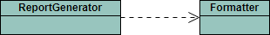

When to Draw Class Diagram?
Most of the UML diagrams can not be mapped directly with any object-oriented programming languages except class diagrams. In other words, class diagram ideally can have one to one mapping to UML class diagrams. Besides, class diagrams are useful in the following situations:
- Describing the static view of the system.
- Modeling the collaboration among the elements of the static view.
- Describing the functionalities performed by the system.
- Construction of software applications using object oriented languages.
- Performing code forward engineering for the target systems
- Classifying classes or components as library for future reuses

How to Draw a Class Diagram?
- Identify the objects in the problem domain, and create classes for each of them. (e.g. Teacher, Student, Course for an enrollment system)
- Add attributes for those classes (e.g. name, address, telephone for the Student class)
- Add operations for those classes (e.g. addStudent(student) for the Course class)
- Connect the classes with appropriate relationships (e.g. Relate Teacher and Course with an association)
- Optionally specify the multiplicities for association connectors' ends (e.g. Input 0..3 for the Course side of the association that connects Teacher and Course, to signify that one teacher can teach multiple up to three courses)
You can also:
- Draw packages for logical categorization of classes
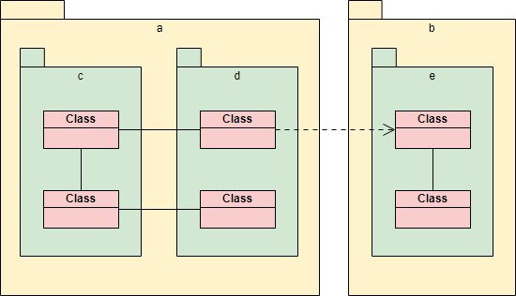

Class Diagram Examples
The class diagram example below shows the classes involved in a sales order system. Notice the use of <<enumeration>> class in the class model.
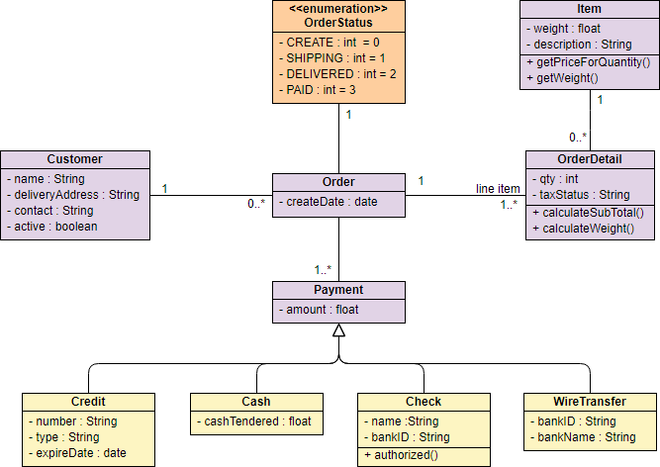

The class diagram example below shows a set of classes related to flight management. The classes are grouped under a package.
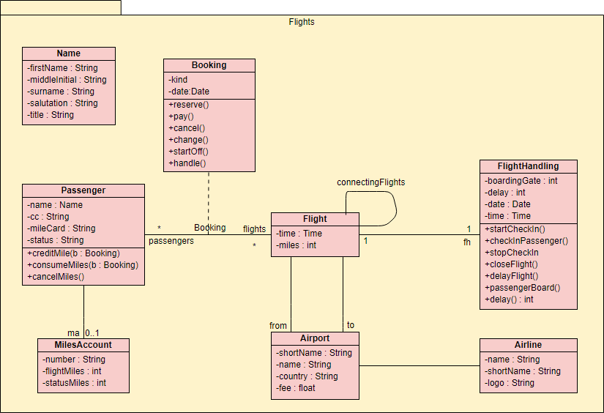

UML Association Vs Aggregation Vs Composition
Consider the differences and similarities between the classes of the following objects: pets, dogs, tails, owners.
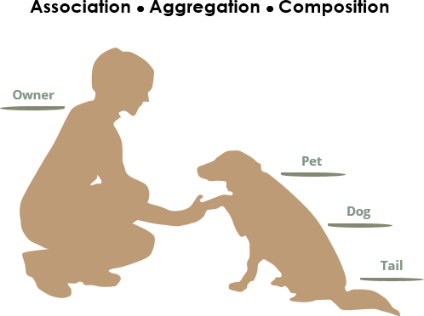
We see the following relationships:
- owners feed pets, pets please owners (association)
- a tail is a part of both dogs and cats (aggregation / composition)
- a cat is a kind of pet (inheritance / generalization)
The figure below shows the three types of association connectors: association, aggregation, and composition. We will go over them in this UML guide.
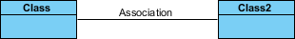
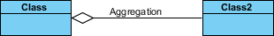
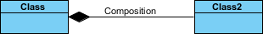
The figure below shows a generalization. We will talk about it later on in this UML guide.
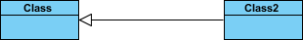

Association
If two classes in a model need to communicate with each other, there must be a link between them, and that can be represented by an association (connector).
Association can be represented by a line between these classes with an arrow indicating the navigation direction. In case an arrow is on both sides, the association is known as a bidirectional association.
We can indicate the multiplicity of an association by adding multiplicity adornments to the line denoting the association. The example indicates that a Student has one or more Instructors:
A single student can associate with multiple teachers:
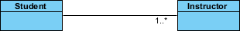
The example indicates that every Instructor has one or more Students:
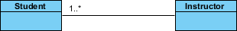
We can also indicate the behavior of an object in an association (i.e., the role of an object) using role names.
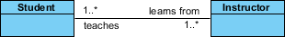

Association vs Aggregation vs Composition
The question "What is the difference between association, aggregation, and composition" has been frequently asked lately.
Aggregation and Composition are subsets of association meaning they are specific cases of association. In both aggregation and composition object of one class "owns" object of another class. But there is a subtle difference:
- Aggregation implies a relationship where the child can exist independently of the parent. Example: Class (parent) and Student (child). Delete the Class and the Students still exist.
- Composition implies a relationship where the child cannot exist independent of the parent. Example: House (parent) and Room (child). Rooms don't exist separate to a House.

Composition Example:
We should be more specific and use the composition link in cases where in addition to the part-of relationship between Class A and Class B - there's a strong lifecycle dependency between the two, meaning that when Class A is deleted then Class B is also deleted as a result
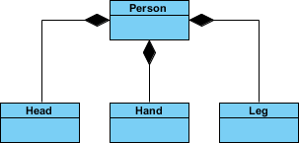

Aggregation Example:
It's important to note that the aggregation link doesn't state in any way that Class A owns Class B nor that there's a parent-child relationship (when parent deleted all its child's are being deleted as a result) between the two. Actually, quite the opposite! The aggregation link is usually used to stress the point that Class A instance is not the exclusive container of Class B instance, as in fact the same Class B instance has another container/s.
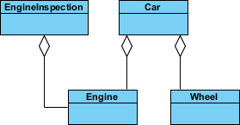
Summing it up -
To sum it up association is a very generic term used to represent when one class used the functionalities provided by another class. We say it's a composition if one parent class object owns another child class object and that child class object cannot meaningfully exist without the parent class object. If it can then it is called Aggregation.

Generalization vs Specialization
Generalization is a mechanism for combining similar classes of objects into a single, more general class. Generalization identifies commonalities among a set of entities. The commonality may be of attributes, behavior, or both. In other words, a superclass has the most general attributes, operations, and relationships that may be shared with subclasses. A subclass may have more specialized attributes and operations.
Specialization is the reverse process of Generalization means creating new sub-classes from an existing class.
For Example, a Bank Account is of two types - Savings Account and Credit Card Account. Savings Account and Credit Card Account inherit the common/ generalized properties like Account Number, Account Balance, etc. from a Bank Account and also have their specialized properties like unsettled payment etc.
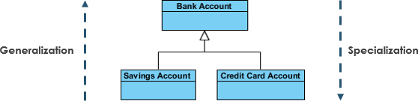

Generalization vs Inheritance
Generalization is the term that we use to denote abstraction of common properties into a base class in UML. The UML diagram's Generalization association is also known as Inheritance. When we implement Generalization in a programming language, it is often called Inheritance instead. Generalization and inheritance are the same. The terminology just differs depending on the context where it is being used.

